**SQL Tasks**

A) Marketing Analysis:

1. Loyal User Reward: The marketing team wants to reward the most loyal users, i.e., those who have been using the platform for the longest time.

Your Task: Identify the five oldest users on Instagram from the provided database.

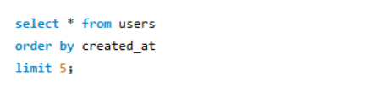

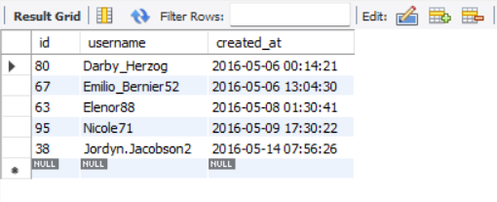

1. Inactive User Engagement: The team wants to encourage inactive users to start posting by sending them promotional emails.

Your Task: Identify users who have never posted a single photo on Instagram.

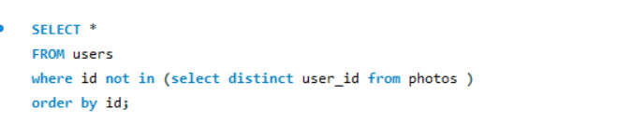

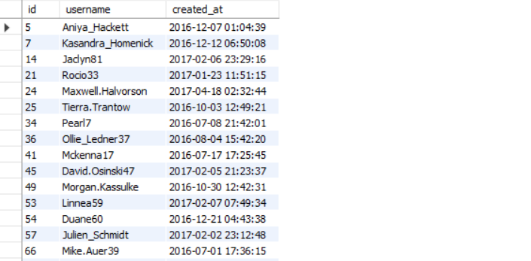

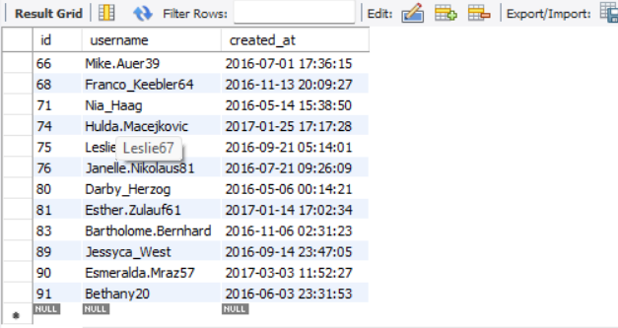

1. Contest Winner Declaration: The team has organized a contest where the user with the most likes on a single photo wins.

Your Task: Determine the winner of the contest and provide their details to the team.

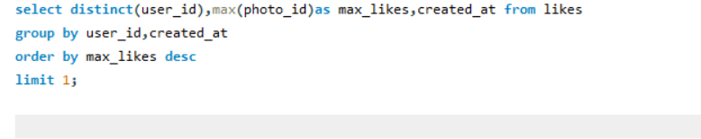

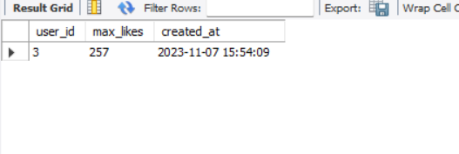

1. Hashtag Research: A partner brand wants to know the most popular hashtags to use in their posts to reach the most people.

Your Task: Identify and suggest the top five most commonly used hashtags on the platform.

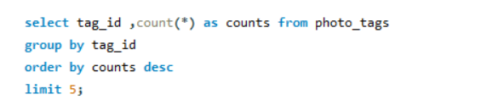

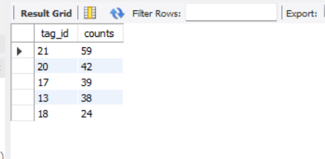

1. Ad Campaign Launch: The team wants to know the best day of the week to launch ads.

Your Task: Determine the day of the week when most users register on Instagram. Provide insights on when to schedule an ad campaign.

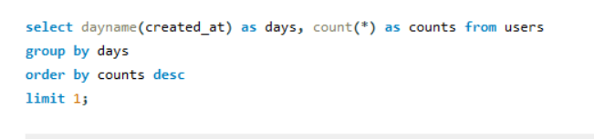

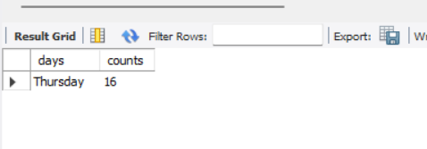

B) Investor Metrics:

1. User Engagement: Investors want to know if users are still active and posting on Instagram or if they are making fewer posts.

Your Task: Calculate the average number of posts per user on Instagram. Also, provide the total number of photos on Instagram divided by the total number of users.

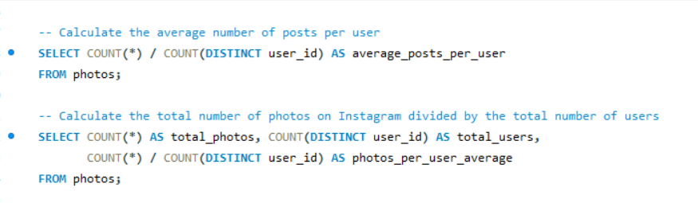

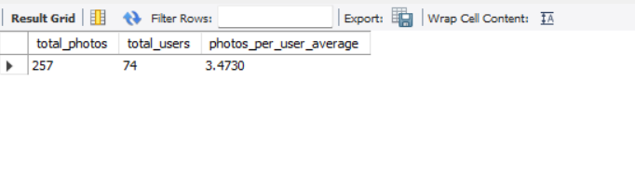

1. Bots & Fake Accounts: Investors want to know if the platform is crowded with fake and dummy accounts.

Your Task: Identify users (potential bots) who have liked every single photo on the site, as this is not typically possible for a normal user.

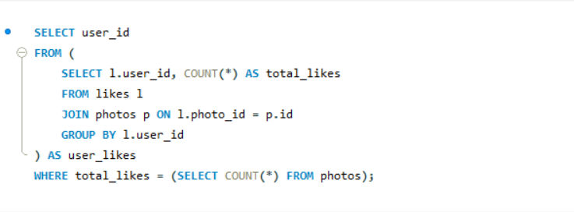

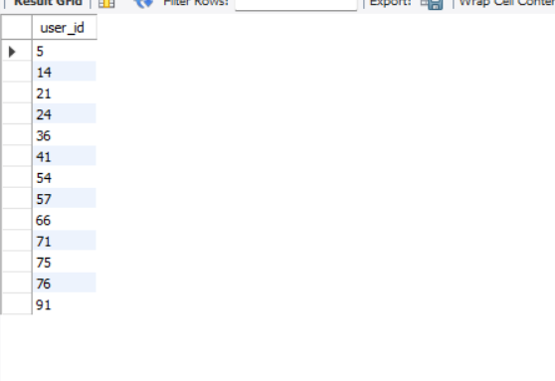

SQL Queries

use ig_clone;

select * from users

order by created_at

limit 5;

SELECT *

FROM users

where id not in (select distinct user_id from photos )

order by id;

select user_id,max(photo_id)as max_likes from likes

group by user_id

order by max_likes desc

limit 0;

select tag_id ,count(*) as counts from photo_tags

group by tag_id

order by counts desc

limit 5;

select dayname(created_at) as days,count(*) as counts from users

group by days

order by counts desc

limit 1;

-- Calculate the average number of posts per user

SELECT COUNT(*) / COUNT(DISTINCT user_id) AS average_posts_per_user

FROM photos;

-- Calculate the total number of photos on Instagram divided by the total number of users

SELECT COUNT(*) AS total_photos, COUNT(DISTINCT user_id) AS total_users,

COUNT(*) / COUNT(DISTINCT user_id) AS photos_per_user_average

FROM photos;

SELECT user_id

FROM (

SELECT l.user_id, COUNT(*) AS total_likes

FROM likes l

JOIN photos p ON l.photo_id = p.id

GROUP BY l.user_id

) AS user_likes

WHERE total_likes = (SELECT COUNT(*) FROM photos);